Ajay Rastogi

KSPL_1235

Section-A

1. 5
2. 1,3,4,5
3. 2
4. 3
5. 3
6. 1
7. 1,3,4
8. 4
9. 1
10. 3
11. 2
12. 2,3,4
13. 1
14. 2
15. 1
16. 4
17. 1
18. 2
19. 3
20. 4

Section-B

1. **Validation Rules (15 Marks)**
2. Only Admins should be allowed to change the account owner.

Error Message : "You are not authorized to transfer the account."

Answer:-

Step 1:-Create an another user in user Setup >Administer > Manage Users >Users.

Step 2:-Go to account validation and write down the validation rule

ISCHANGED (OwnerId)&& NOT( ISNEW() ) and show error message :- You are not authorized to transfer the account.

Step 3:-Create an account name:-Account3

Step 4:-And when we edit the account owner it can’t be change and show mgs on the screen.

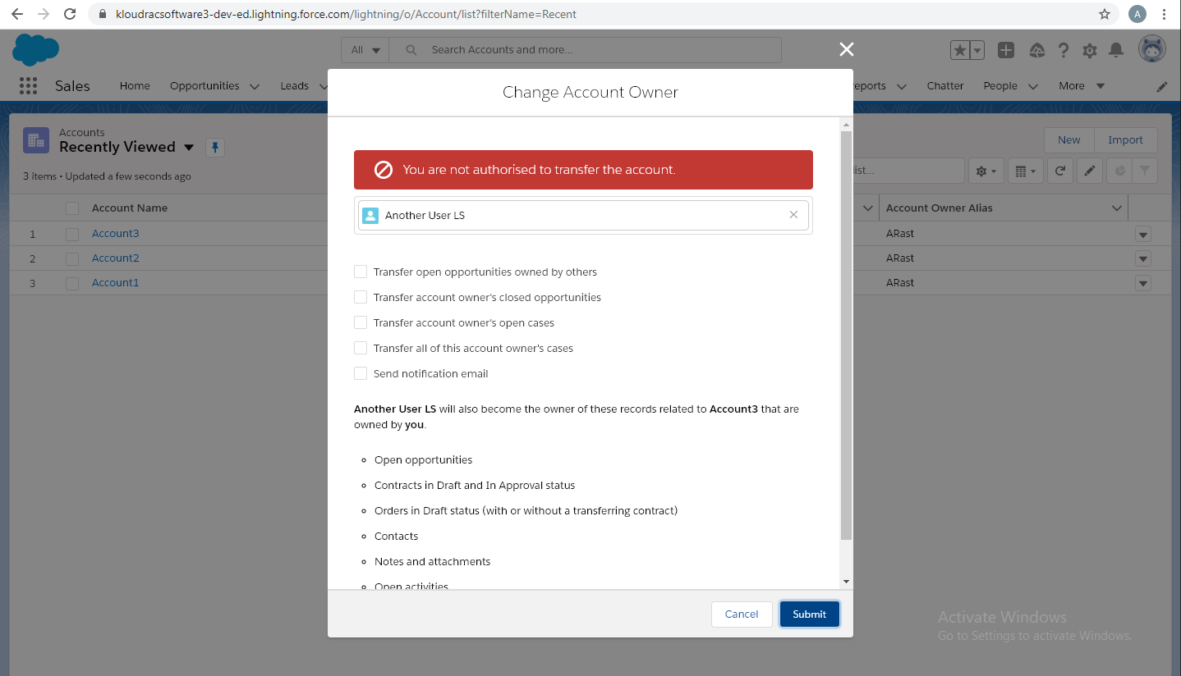

Question 2:- **Workflow Rule (5 Marks)**

If Amount > $10,000 send an email alert on opportunity **closed won (Stage field value)** to pgoyal@kloudrac.com and msharma@kloudrac.com

Email Template .

Subject : Deal closed Alert - $Amount - Opportunity Name

Opportunity Name :

Account Name :

Account Owner :

Amount :

Close Date :

Best Regards

Salesforce Team - Kloudrac

Answer- 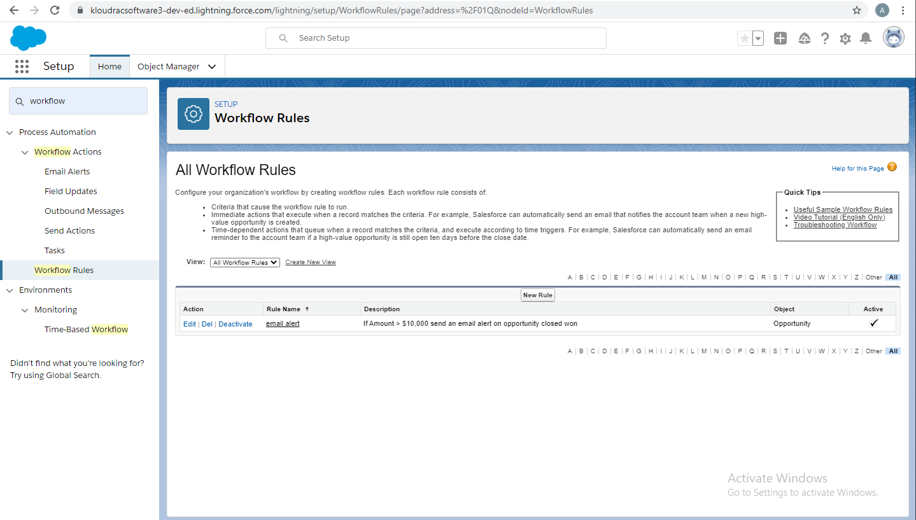

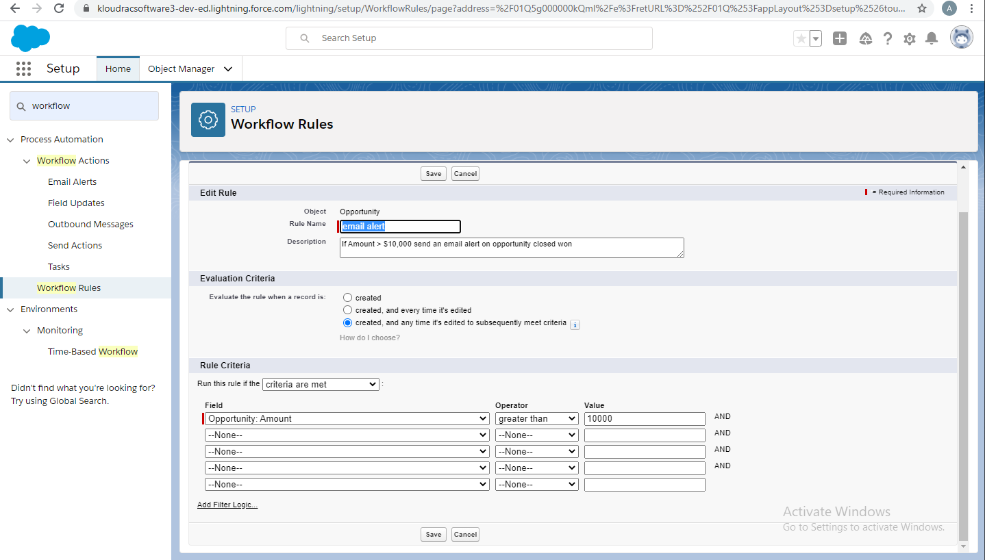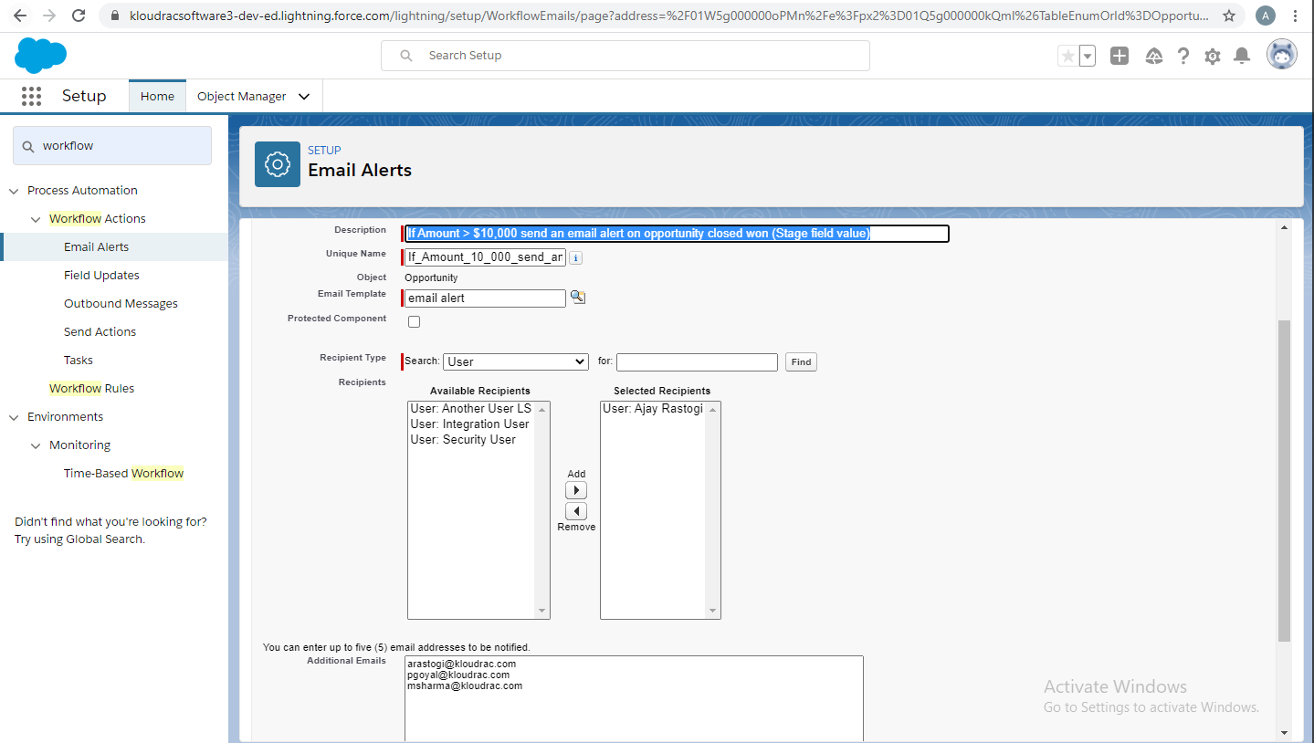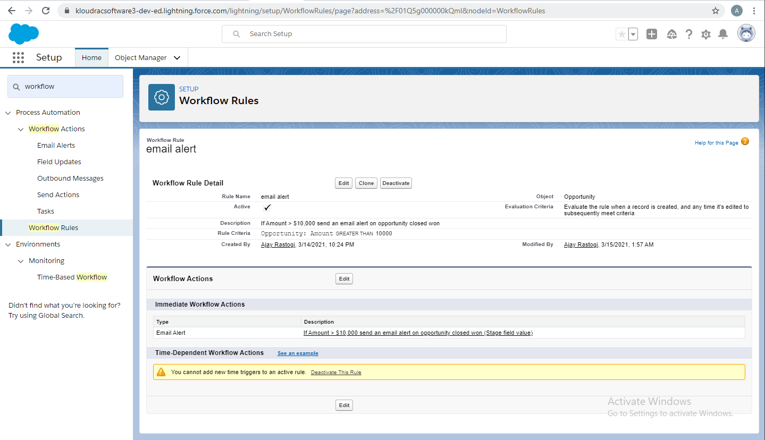

1. **Process Builder (10 Marks)**

Kloudrac Softwares would like to set up a process where an event will get created on opportunity creation and an automated approval will go to the opportunity owner's manager whenever discount > 20% on opportunity.

There is a field Discount, Approval Status on Opportunity.

Default value for Discount - "Approval Not Required".

When Discount is greater than your allowed matrix - "Approval Required"

When submitted for approval - "Approval Pending"

When Approved / Rejected - "Approved / Rejected”

Solution:-

